December 10, 2025

Dear Parents, Players, and Spectators:

On behalf of the Wytheville Parks and Recreation Department, we would like to welcome each of you to our 2025 Winter Basketball season! Please remember that throughout the season, our collective goal is to promote and develop teamwork, skills, and good sportsmanship in an enjoyable and healthy learning environment for the kids. We are all looking forward to a fun and exciting season. Thank you in advance for your continued assistance and support throughout this season.

Placement Practice:
2nd & 3rd Grade Boys: Monday, December 29, 5:30-6:30 pm
6th & 7th Grade Girls: Tuesday, December 30, 5:30-6:30 pm
6th & 7th Grade Boys: Tuesday, December 30, 6:45-7:45 pm
All placement practice will be held at the Wytheville Community Center on Court 2.

Once teams are selected, your coach will contact you to let you know when practices begin. Your coach should contact you within two days of your placement practice. Please join the team band app when you receive the invite from your coach as this is where practice schedules, game schedules and communication from the coach will take place. Also, don’t forget to join the band app for general athletic communications which is listed on the back.
A few things to remember:

- We want to remind everyone that this is a recreation league that is here for the kids to most importantly learn the fundamentals, techniques, and build on skills while having fun.
- The Code of Ethics should be signed by both parents and the players before the first basketball placement practice. If you have not done so, please sign and return to the front desk prior to your first placement practice.
- Uniforms including jerseys are to be returned to the Athletic Coordinator following your child’s last game of the season. Come prepared with a change of clothes.
- All parents and spectators are not allowed in the player’s area and must remain in the stands or spectator area during games.
- If games are cancelled due to inclement weather, we will notify the coaches, who will notify the players and update the band app, see information on back about our band apps.
- Like us on Facebook for updates, information and pictures throughout the season.
- You can find our basketball league rules at: https://rec.wytheville.org/athletics under the athletics section

If there are any questions, concerns, ideas or issues, please contact the Athletic Coordinator, Keaton Alderman at Keaton.alderman@wytheville.org or (276) 223-3518

Team Band App Communications
- Invite will be sent from your coach
- Updates on practice and game schedules
- Updates on cancellations or rescheduling

Team Band App Communications
- Updates on registration information
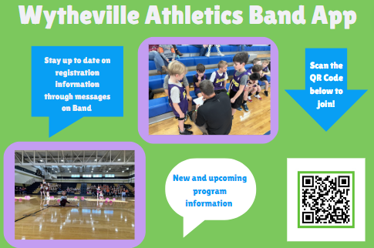
- New and upcoming programs

